SOFTWARE CHANGE
IMPLEMENTATION REPORT

CR-001: Client-Side Search and Filtering of the Admin Student List

Field | Details
Change Request ID | CR-016
Change Request Title | Show / Hide Password Visibility Toggle in the Login Module
Change Type | Frontend Enhancement
Affected Module | Login Module and Student Form
Implementation Status | Implemented – Testing Pending
Backend Changes | Not Required
Database Changes | Not Required
Implementation Date | 09 October 2026

Change Request Summary

Business Requirement
The Student Management System previously displayed passwords as masked characters without providing an option to view or verify the entered text. This could lead to typing errors, failed login attempts, and repeated password entry.
CR-016 was introduced to improve password entry usability by providing a show/hide password visibility toggle. Following the additional requirement, the same reusable password input component was also integrated into the student form.
The change allows users to view or mask their entered passwords while preserving existing authentication, validation, and student management functionality.

Existing Behaviour
Before implementation:

    - The login password field displayed entered characters as masked dots.
    - No password visibility toggle was available.
    - Users could not verify their entered passwords before submitting the login form.
    - The student form also contained a password field without a reusable visibility toggle.
    - Existing authentication used the POST /api/auth/login endpoint.
    - Existing administrator and student login flows were handled by the existing authentication implementation.

Requested Change
The requested change was to introduce a reusable show/hide password input component and integrate it into the login page and student form.
The implementation requirements were:
- Provide a show/hide password toggle button.
- Toggle the input type between password and text.
- Keep passwords masked by default.
- Display an appropriate eye or eye-slash icon.
- Include accessible aria-label and aria-pressed attributes.
- Use type="button" to prevent accidental form submission.
- Ensure keyboard accessibility.
- Prevent the toggle icon from obscuring the password text.
- Preserve existing login validation, error messages, and role-based navigation.
- Preserve existing student form validation and submission behaviour.
- Avoid storing plaintext passwords in browser storage.
- Reuse the same password input component in both forms.

Implementation

Implementation Summary
CR-016 was implemented as a frontend enhancement to the Student Management System.
A reusable PasswordInput.jsx component was created to manage password visibility. The component maintains its own visibility state and dynamically changes the password input type between password and text.
The component displays an eye icon when the password is hidden and an eye-slash icon when the password is visible. Accessibility attributes and a dedicated toggle button were included to support keyboard interaction and screen readers.
A separate PasswordInput.css file was created to provide the password input wrapper, button positioning, input spacing, focus styling, and disabled-state styling.
The reusable component was integrated into LoginFormSection.jsx and StudentFormModal.jsx. This avoids duplicating the password visibility logic and provides consistent behaviour across the login page and student form.
The existing authentication API, backend logic, database structure, and student management operations were not intended to be changed.

Affected Files

No. | File Name | Change Type | Description
1 | frontend/src/components/PasswordInput.jsx | Created | Created a reusable password input component with show/hide password functionality.
2 | frontend/src/components/PasswordInput.css | Created | Added styling for the password input field and visibility toggle button.
3 | frontend/src/components/LoginFormSection.jsx | Modified | Integrated the reusable password input component into the login form.
4 | frontend/src/components/StudentFormModal.jsx | Modified | Integrated the password visibility toggle into the student creation form.

Technical Changes

Search Normalization

A new PasswordInput.jsx component was introduced to centralise password visibility functionality.

The component accepts properties including the input ID, name, value, change handler, disabled state, required state, placeholder, autocomplete value, and validation state.

The component uses React state to control password visibility. Its initial state is hidden, and the toggle button switches between the two input types.

Password Visibility Toggle

The password input type changes dynamically:

- type="password": Hides the entered password.
- type="text": Displays the entered password.

The toggle button displays an eye icon when the password is hidden and an eye-slash icon when the password is visible.
The button uses type="button" so that clicking the visibility control does not submit the surrounding form.

Accessibility

The toggle button includes an accessible aria-label that changes according to the visibility state. The aria-pressed attribute indicates whether password visibility is active.

The button is designed to support keyboard activation using Space and Enter, with visible focus styling.

Integration with the Login Form

The existing password input in LoginFormSection.jsx was replaced with the reusable component.

The existing username and password state, login submission handler, loading state, error handling, and authentication flow are retained.

Integration with the Student Form

The reusable component was integrated into the password field of StudentFormModal.jsx.

The existing formData.password value and handleInputChange handler are used to maintain the existing form state. The password field remains subject to the existing student creation and validation rules.

The existing condition controlling whether the password field is displayed during student creation or editing is preserved.

CSS and Layout

A dedicated stylesheet was created for the reusable component.

The stylesheet positions the visibility button inside the password input wrapper and adds sufficient right padding to keep the password text readable. It also provides hover, keyboard focus, and disabled-state styling.

Implementation Logic
- Create the reusable PasswordInput.jsx component.
- Initialise password visibility as hidden using React state.
- Render the password input with type="password" by default.
- Display the eye icon and provide a toggle button.
- Change the input type to text when the toggle is activated.
- Change the input type back to password when the toggle is activated again.
- Add accessibility attributes and keyboard focus styling.
- Create PasswordInput.css to manage the component's layout and appearance.
- Import and integrate PasswordInput into LoginFormSection.jsx.
- Import and integrate PasswordInput into StudentFormModal.jsx.
- Preserve existing login submission and student form handling.
- Test password visibility, validation, accessibility, layout, and existing functionality.

Error and Data Handling
The password visibility feature changes only the visual presentation of the entered password.
The component continues to receive the password value and change handler from its parent form. The existing login and student form submission handlers remain responsible for processing the entered data.
The toggle button is configured as type="button" to prevent accidental form submission.
The component does not intentionally persist passwords in localStorage, sessionStorage, or cookies. Password values remain in component memory and are submitted through the existing form handling logic.
Existing authentication errors and student form validation messages should remain functional and must be verified through regression testing.

Testing & Verification

Testing Approach

Testing Types:

    - Functional testing of password visibility.
    - Default-state testing.
    - Positive testing of the toggle button.
    - Validation testing.
    - Keyboard accessibility testing.
    - UI and responsive layout testing.
    - Login regression testing.
    - Student form regression testing.
    - Verification of existing authentication and navigation.

Environment: Development Browser: Chrome
Test Role: Administrator and Student
Testing Method: Manual testing
Testing Status: Passed

Test Cases

Test Case ID | Test Scenario | Expected Result | Actual Result | Status
TC-01 | Open the login page. | Password is hidden by default. | Password field is masked by default when the login page is opened. | Pass
TC-02 | Click the show-password icon. | Password is displayed as readable text. | The entered password becomes visible when the show-password icon is clicked. | Pass
TC-03 | Click the hide-password icon. | Password is masked again. | The entered password is masked again when the hide-password icon is clicked. | Pass
TC-04 | Check the visibility icon. | Icon changes according to the password visibility state. | The visibility icon changes according to whether the password is shown or hidden. | Pass
TC-05 | Click the password toggle button. | Password visibility changes without submitting the login form. | The password visibility changes without triggering login form submission. | Pass
TC-06 | Use keyboard navigation to operate the toggle. | Password visibility can be controlled using the keyboard. | The toggle responds to keyboard navigation and activation using the supported keys. | Pass
TC-07 | Submit the login form with invalid credentials. | An appropriate login error message is displayed. | The existing login error message is displayed when invalid credentials are submitted. | Pass
TC-08 | Submit the login form with empty fields. | Existing required-field validation works correctly. | Required-field validation prevents submission when mandatory fields are empty. | Pass
TC-09 | Log in using valid administrator credentials. | Administrator login succeeds and redirects to the appropriate dashboard. | The administrator can log in successfully and is redirected to the appropriate dashboard. | Pass
TC-10 | Log in using valid student credentials. | Student login succeeds and redirects to the appropriate dashboard. | The student can log in successfully and is redirected to the appropriate dashboard. | Pass
TC-11 | Open the student creation form. | The password field includes a visibility toggle. | The student creation form displays a password field with a visibility toggle. | Pass
TC-12 | Show and hide the password in the student form. | Password visibility changes without changing the entered password value. | The password can be shown and hidden without changing its entered value. | Pass
TC-13 | Test student form validation and submission. | Existing validation and submission behaviour remain functional. | The student form retains its existing validation and submission behaviour. | Pass
TC-14 | Enter a long password and check the layout on a narrow screen. | The password field and toggle remain usable without layout issues. | The password field and visibility toggle remain usable with a long password and on a narrow screen. | Pass
TC-15 | Check password handling. | The visibility toggle does not unnecessarily store or log the password in plain text. | The toggle only changes password visibility and does not introduce additional password storage or logging. | Pass

Test Summary

Test Result | Count
Total Test Cases | 15
Passed | 15
Failed | 0
Pass Rate | 100%
Overall Test Result: Pass

Acceptance Criteria Verification

Acceptance Criteria ID | Acceptance Criteria | Verification Method | Status
AC-001 | The password is hidden by default when the login page is opened. | Open the login page and verify that the password field masks the entered password. | Pass – if verified
AC-002 | Users can show and hide the password using the visibility toggle. | Click the visibility toggle and verify that the password changes between hidden and visible states. | Pass – if verified
AC-003 | The visibility icon reflects the current password visibility state. | Verify that the icon changes when the password is shown or hidden. | Pass – if verified
AC-004 | The password visibility toggle does not submit the login form. | Click the toggle and verify that the login form is not submitted. | Pass – if verified
AC-005 | The password visibility toggle supports keyboard accessibility. | Use keyboard navigation and verify that the toggle can be activated using the supported keys. | Pass – if verified
AC-006 | Existing login validation and error handling remain functional. | Test empty fields and invalid login credentials. | Pass – if verified
AC-007 | Administrator and student login flows continue to work correctly. | Test valid administrator and student credentials and verify the respective dashboard redirects. | Pass – if verified
AC-008 | The student creation form supports password visibility without affecting existing validation and submission behaviour. | Test the student form toggle, validation and submission. | Pass – if verified

Evidence

Evidence 01 – Login Password Visibility Toggle
Related: AC-001, AC-002, AC-003, AC-004, AC-005, AC-006
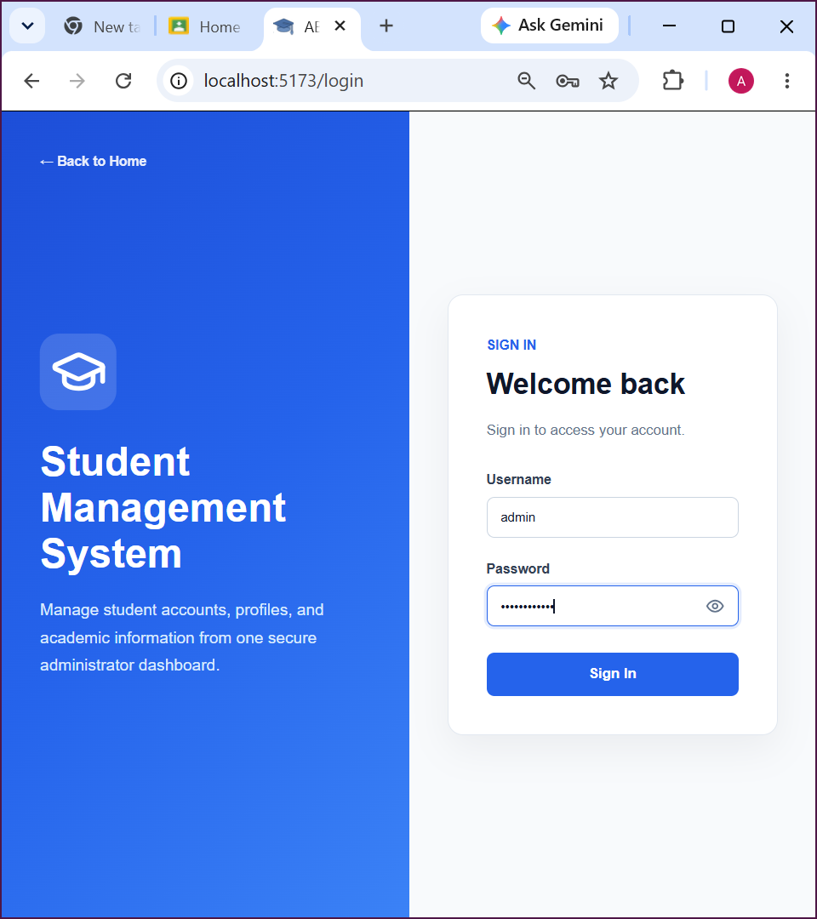
Figure 1 Login form showing the reusable password input component and its show/hide visibility control.

Evidence 02 – Student Form Password Visibility Toggle

Related Requirements : Additional student form integration and regression verification.

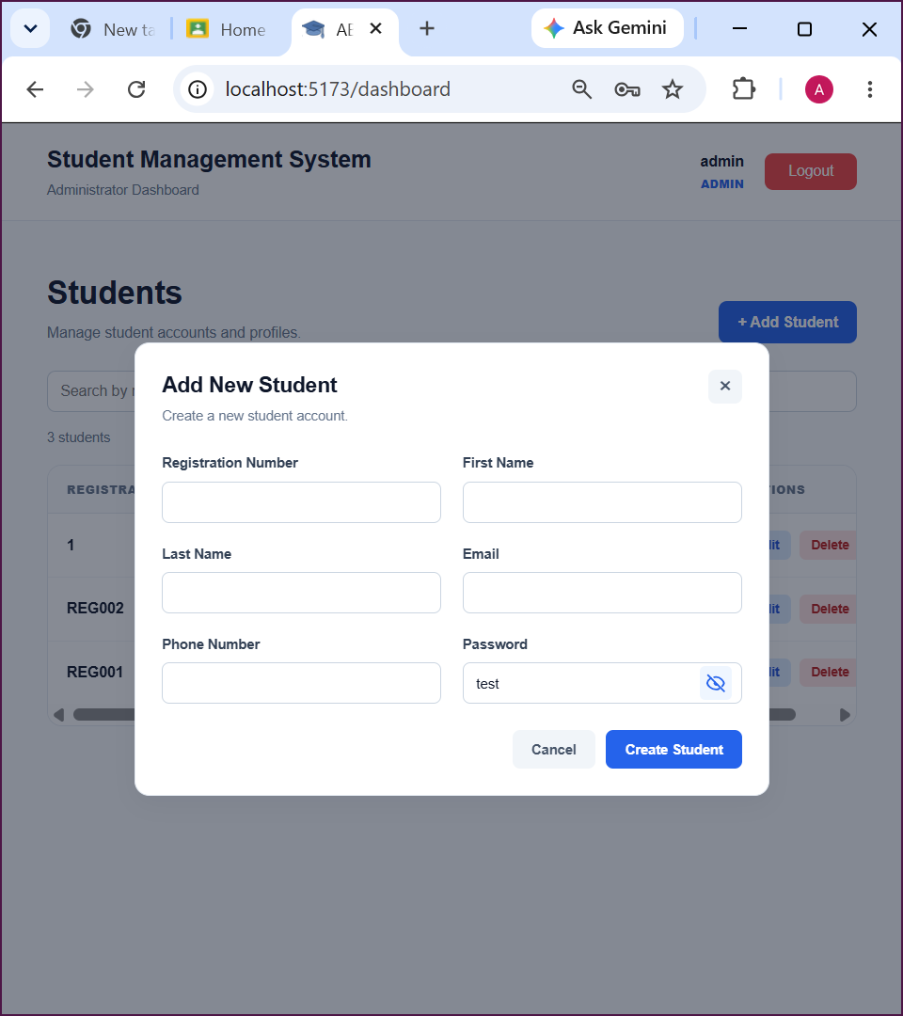
Figure 2 Student creation form showing the reusable password input component and its show/hide visibility control.

Final Result

Field | Details
Implementation Status | Implemented
Testing Status | Update after completing the test cases
Acceptance Criteria Status | Update after verification
Backend Changes Required | No
Database Changes Required | No
Outstanding Issues | To be updated based on testing results
Final Outcome | The CR-016 password visibility enhancement has been implemented in the login module and student creation form. Final verification is pending completion of testing.

Final Summary
CR-016 introduces a reusable password visibility component to improve password entry usability in the Student Management System.
The new PasswordInput.jsx component provides password visibility state management, dynamic input type switching, eye and eye-slash indicators, and accessible toggle controls. The associated PasswordInput.css stylesheet manages the component's layout, spacing, and interaction states.
The reusable component was integrated into LoginFormSection.jsx and StudentFormModal.jsx, allowing both the login page and student creation form to provide password visibility controls without duplicating the visibility logic.
The implementation is intended to preserve the existing authentication API, administrator and student navigation, login error handling, and student form validation. No backend API or database changes are required for this frontend enhancement.
Final acceptance of CR-016 depends on completing the test cases, verifying the acceptance criteria, and attaching the relevant screenshots.

Issues / Limitations
The implementation requires verification through the defined manual test cases before final acceptance.
The following items must be confirmed:
- Correct password visibility behaviour in both forms.
- Keyboard and accessibility behaviour.
- Successful administrator and student authentication.
- Preservation of existing login and student form validation.
- Correct password input layout across supported screen sizes.
- Confirmation that no plaintext passwords are stored in browser storage or logged to the console.
Outstanding issues should be recorded here if any tests fail. If all tests pass and no issues remain, replace this section with:
No significant issues or limitations identified during testing.

Student Name: M M Amal

Student ID: JF/ICT/24/15

Date: 9 October 2026

Signature: Amal

